**Chapter 5**

**Multiple Integration**

**5.6 Calculating Centers of Mass and Moments of Inertia**

**Section Exercises**

**In the following exercises, the region  occupied by a lamina is shown in a graph. Find the mass of  with the density function .**

297.  is the triangular region with vertices  and 

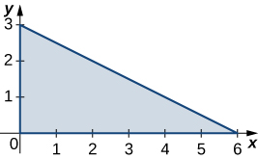

Answer: 

298.  is the triangular region with vertices 

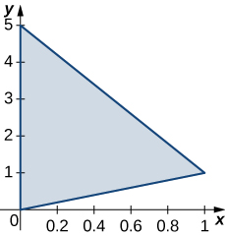

Answer:

299.  is the rectangular region with vertices  and  

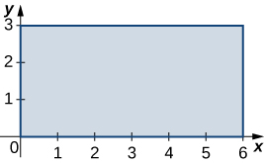

Answer:

300.  is the rectangular region with vertices  and  

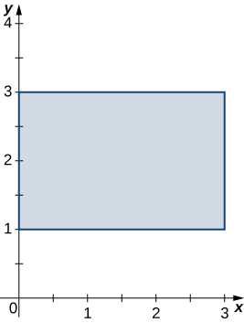

Answer:

301.  is the trapezoidal region determined by the lines  and 

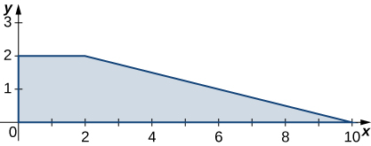

Answer:

302.  is the trapezoidal region determined by the lines  and 

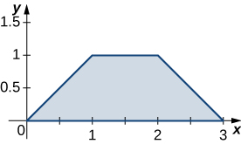

Answer: 

303.  is the disk of radius  centered at ; 

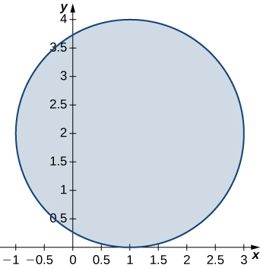

Answer:

304.  is the unit disk;

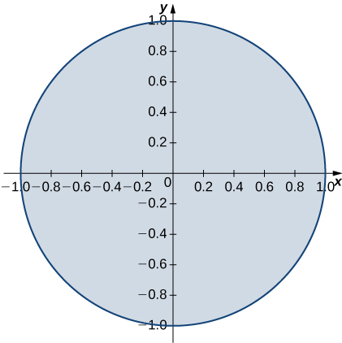

Answer: 

305.  is the region enclosed by the ellipse 

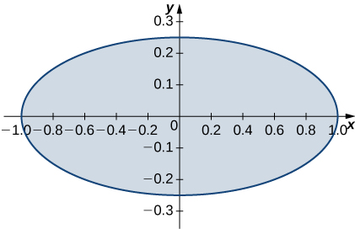

Answer: 

306.  

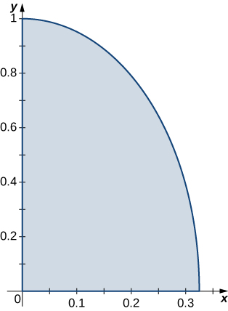

Answer:

307.  is the region bounded by 

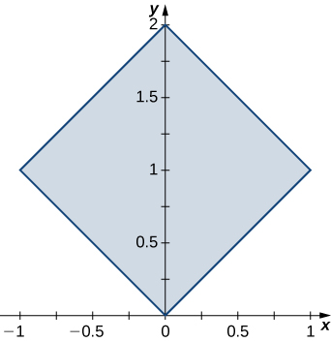

Answer:

308.  is the region bounded by  and 

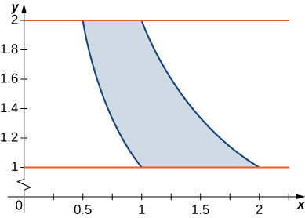

Answer:

**In the following exercises, consider a lamina occupying the region  and having the density function  given in the preceding group of exercises. Use a computer algebra system (CAS) to answer the following questions.**

1. **Find the moments and about the  and respectively.**
2. **Calculate and plot the center of mass of the lamina.**
3. **[T] Use a CAS to locate the center of mass on the graph of*.***

309. **[T]**  is the triangular region with vertices  and 

Answer: a. b.

c.

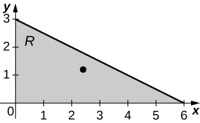

310. **[T]**  is the triangular region with vertices

Answer: a.  b.

c.

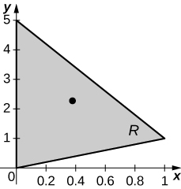

311. **[T]**  is the rectangular region with vertices   .

Answer: a. b.

c.

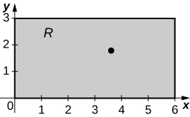

312. **[T]**  is the rectangular region with vertices  

Answer: a. b.

c.

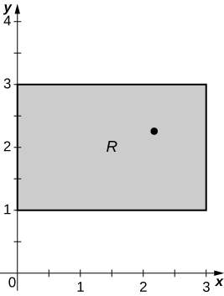

313. **[T]**  is the trapezoidal region determined by the lines   

Answer: a.  b.

c.

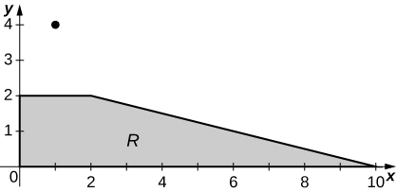

314. **[T]**  is the trapezoidal region determined by the lines and.

Answer: a.  b. 

c.

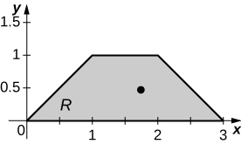

315. **[T]**  is the disk of radius  centered at .

Answer: a.  b. ;

c.

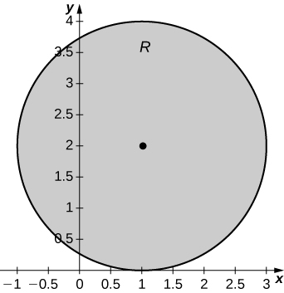

316. **[T]**  is the unit disk; 

Answer: a. , ; b.

c.

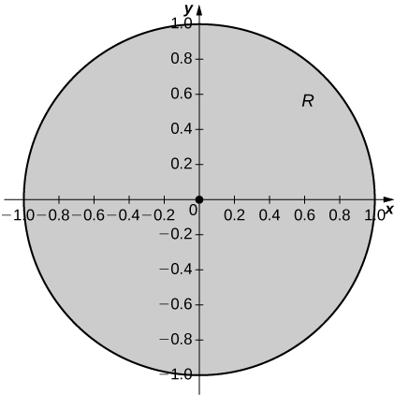

317. **[T]**  is the region enclosed by the ellipse 

Answer: a.  b. 

c.

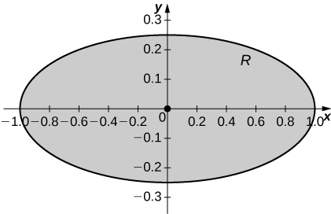

318. **[T]** 

Answer: a. b.

c.

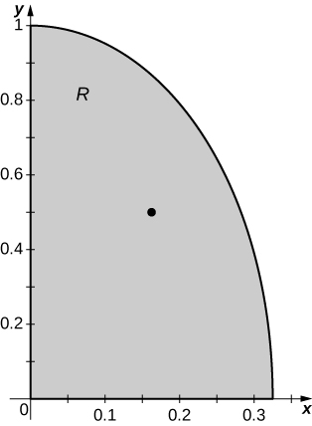

319. **[T]**  is the region bounded by  and  

Answer: a.  b. 

c.

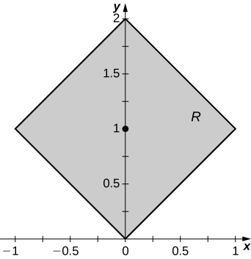

320. **[T]**  is the region bounded by ,  

Answer: a. b. 

c.

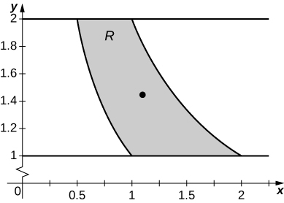

**In the following exercises, consider a lamina occupying the region  and having the density function  given in the first two groups of Exercises.**

1. **Find the moments of inertia and  about the, , and origin, respectively.**
2. **Find the radii of gyration with respect to the, , and origin, respectively.**

321.  is the triangular region with vertices  and 

Answer: a.  b. 

322.  is the triangular region with vertices and 

Answer: a.  b. 

323.  is the rectangular region with vertices  and 

Answer: a.  b. 

324.  is the rectangular region with vertices and 

Answer: a. b. 

325.  is the trapezoidal region determined by the lines  and 

Answer: a. b.  and 

326.  is the trapezoidal region determined by the lines  and .

Answer: a.  b.  and 

327.  is the disk of radius  centered at ;.

Answer: a.  b.  and 

328.  is the unit disk;.

Answer: a.  b. 

329.  is the region enclosed by the ellipse .

Answer: a.  b. 

330. 

Answer: a.  b. 

331.  is the region bounded by  .

Answer: a.  b. 

332.  is the region bounded by.

Answer: a.  b. 

333. Let  be the solid unit cube. Find the mass of the solid if its density is equal to the square of the distance of an arbitrary point of  to the.

Answer:

334. Let  be the solid unit hemisphere. Find the mass of the solid if its density  is proportional to the distance of an arbitrary point of  to the origin.

Answer:

335. The solid  of constant density  is situated inside the sphere  and outside the sphere. Show that the center of mass of the solid is not located within the solid.

Answer: This is a proof; therefore, no answer is provided.

336. Find the mass of the solid  whose density is  where .

Answer:

337. **[T]** The solid  has density equal to the distance to the  Use a CAS to answer the following questions.

1. Find the mass of .
2. Find the moments  about the and respectively.
3. Find the center of mass of.
4. Graph  and locate its center of mass.

Answer: a. ; b. c. d. the solid ** and its center of mass are shown in the following figure.

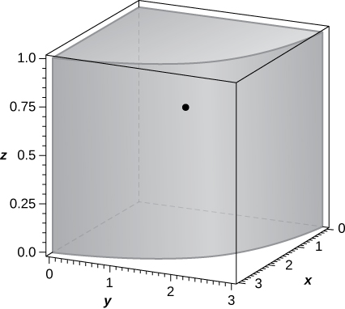

338. Consider the solid  with the density function .

1. Find the mass of.
2. Find the moments about theplane,plane, and plane, respectively.
3. Find the center of mass of.

Answer: a.; b. , ,; c.

339. **[T]** The solid  has the mass given by the triple integral . Use a CAS to answer the following questions.

1. Show that the center of mass of  is located in the plane.
2. Graph  and locate its center of mass.

Answer: a.; b. the solid  and its center of mass are shown in the following figure.

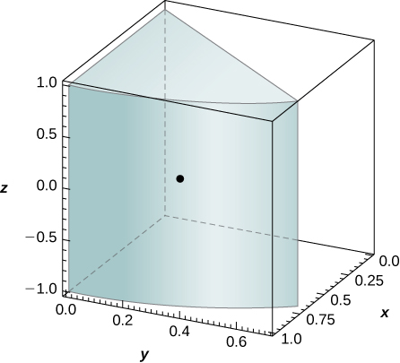

340. The solid  is bounded by the planes  Its density at any point is equal to the distance to the  Find the moments of inertia  of the solid about the 

Answer:

341. The solid  is bounded by the planes ,  and. Its density is  where . Show that the center of mass of the solid is located in the plane  for any value of.

342. Let  be the solid situated outside the sphere  and inside the upper hemisphere  where . If the density of the solid is , find  such that the mass of the solid is .

Answer: 

343. The mass of a solid  is given by , where  is an integer. Determine  such the mass of the solid is.

Answer: 

344. Let  be the solid bounded above the cone  and below the sphere . Its density is a constant . Find  such that the center of mass of the solid is situated  units from the origin.

Answer:

345. The solid  has the density . Show that the moment  about the  is half of the moment  about the 

Answer: This is a proof; therefore, no answer is provided.

346. The solid  is bounded by the cylinder , the paraboloid , and the  where  Find the mass of the solid if its density is given by .

Answer: 

347. Let  be a solid of constant density  where , that is located in the first octant, inside the circular cone , and above the plane . Show that the moment  about the  is the same as the moment  about the 

Answer: This is a proof; therefore, no answer is provided.

348. The solid  has the mass given by the triple integral 

1. Find the density of the solid in rectangular coordinates.
2. Find the moment about the 

Answer: a. ; b. 

349. The solid  has the moment of inertia  about the  given by the triple integral  .

1. Find the density of 
2. Find the moment of inertia about the plane.

Answer: a.  b.

350. The solid  has the mass given by the triple integral  .

1. Find the density of the solid in rectangular coordinates.
2. Find the moment  about the plane.

Answer: a. b. 

351. Let  be the solid bounded by the , the cylinder , and the plane  where  is a real number. Find the moment  of the solid about the  if its density given in cylindrical coordinates is  where  is a differentiable function with the first and second derivatives continuous and differentiable on 

Answer:

352. A solid  has a volume given by  where  is the projection of the solid onto the  and  are real numbers, and its density does not depend on the variable. Show that its center of mass lies in the plane .

Answer: This is a proof; therefore, no answer is provided.

353. Consider the solid enclosed by the cylinder  and the planes  and , where  and  are real numbers. The density of  is given by , where  is a differential function whose derivative is continuous on . Show that if , then the moment of inertia about the  of  is null.

Answer: This is a proof; therefore, no answer is provided.

354. **[T]** The average density of a solid  is defined as  , where  and  are the volume and the mass of  , respectively. If the density of the unit ball centered at the origin is  use a CAS to find its average density. Round your answer to three decimal places.

Answer:

355. Show that the moments of inertia  about the  and  respectively, of the unit ball centered at the origin whose density is  are the same. Round your answer to two decimal places.

Answer: 

This file is copyright 2016, Rice University. All Rights Reserved.